Welcome to 4th grade at St. Anne-Pacelli Catholic School. I want to thank you for the privilege of teaching your child this upcoming school year. I am looking forward to working with you and hope that your experience will be very enjoyable, as well as fun and exciting!

Communication

Teacher Communication:
Email is the most expedient way to contact me; however, written notes sent through your child are acceptable.

Ms. Paula Frisch
4th Grade Teacher
pfrisch@sasphs.net

Classroom Website:
News of upcoming events, activities, and projected homework/test dates will be posted weekly on our classroom website:
www.4avikings.weebly.com

School Website:
News and quick links to school-wide related events including school news, school calendar, and parental involvement opportunities can be found on our school website:
www.BeAViking.com

Organization & Housekeeping

Covering Books:
The religion book must be covered with contact paper.
It is highly recommended that the following books are also covered:
Being a Writer (2), reading, social studies, science, and math.

School Supplies:
Please be sure that your child has all necessary supplies for class. While each student has their own supply of extra items stored in the classroom, there may be times throughout the school year that lost or used items may need to be replaced.

Class Schedule:
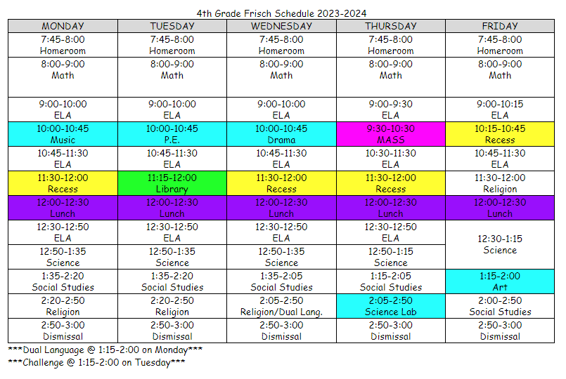

Grading & Responsibilities
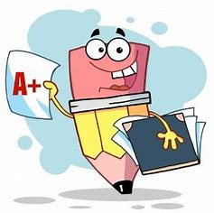

Grading:
Grading Scale for Academic Content Areas:
A – 94-100
B – 86-93
C – 77-85
D – 70-76
F – Below 70

Grading Scale for Special Areas:
S - Satisfactory Progress
N - Needs Improvement
U – Unsatisfactory

In fourth grade, averages are weighted. The weighted average breaks down to 50% achievement assessments and 50% effort assessments. Achievement assessments include tests and quizzes. Effort assessments include homework and classwork. Weekly grades will be posted by 8 am each Monday morning on Powerschool: https://beaviking.powerschool.com/public/home.html

Mastery Learning:

At Saint Anne-Pacelli we follow the model of learning to mastery in education. This means that we want all students to succeed and master content as we continue to build on new skills. Through this model, students develop a growth mindset and can take ownership of their learning.

How do we achieve mastery?
- Pre-assessments are used to evaluate students’ prior knowledge of concepts.
- Targeted lessons on concepts are presented to the whole group and in small groups.
- Students move to small groups and independent practice of concepts.
- Students are evaluated daily through formative means to assess understanding of concepts. They are encouraged to ask questions and engage in meaningful discussion.
- Reteaching and review of concepts occurs as needed to the whole group, small groups, and individual students.
- Students are expected to follow through with assigned classwork and homework (including studying) to practice concepts.

Test Retake Policy:
As part of this model, it is understood that students may just need more time to review the concepts or have an off day when taking a comprehensive test. To this end, we want to be sure to provide the opportunity for students to show what they truly have mastered.

Any student is eligible to request another attempt at mastery if they have completed all required classwork and homework prior to the initial assessment.

Please read the retest guidelines below:
- The request must be made by parent or student upon receipt of the graded test in the Weekly Blue Folder.The retest form must be completed and returned in the Blue Folder the next day.
- The teacher is not responsible for initiating a retest.
- The student must complete the retest of the summative assessment on the date and time assigned by the teacher. The teacher will email the day and time of the retest when the form is returned.
- The format of any summative assessment may be changed for the retest.
- Only one retake for each summative assessment will be given and the highest score will be recorded in PowerSchool.
- This policy applies to tests only, not quizzes or “cold read” assessments.

All requests for a retest must be accompanied by a Summative Assessment Retest Request Form which outlines the student’s responsibility to prepare for the reassessment. These forms can be printed from the class website.

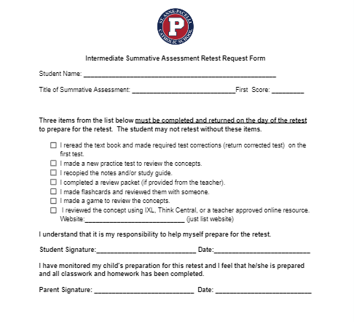

Behavior/Responsibility:
Classroom expectations are used to promote a positive learning environment for all students. Children are responsible for obeying all school rules, playground rules, cafeteria rules, Extended Day rules, Church rules, and classroom rules. Students are also expected to come to school prepared and ready to learn. If a student does not meet the expectations, an item will be marked on the clipboard page. One mark is a warning; at two marks the student will complete a “think sheet” ; three marks result in a parent phone call, email or conference; and at a fourth mark the student will be sent to administration.

Weekly Folders:
Weekly assessments and behavior/responsibility reports will go home each Monday (Tuesday if there is a Monday holiday) in the student’s weekly folder. Please keep the graded papers, sign the report, and return it the following school day. Periodically, some graded papers may be returned directly to the student to be used for studying.

Binders:
Having a well-organized binder is the responsibility of each student. Large quantities of accumulated papers should never be in the front or back pocket of the binder. At the end of each unit, students will be guided by the teacher as to which papers can be removed from the binder. Please do not throw out or remove papers at home.

Student Planners:
Students are responsible for writing their homework assignment in their planners as soon as they enter the classroom.

Uniforms/School-Wide Policies:
For detailed information regarding uniforms and school-wide policies, you may access the lower-school handbook in the school bulletin section of PowerSchool.

Fourth grade reading involves helping the student transition from “learning to read” to “reading to learn.” Reading will be taught through novel studies. Students will work in guided reading groups where they will rotate through work with the teacher, independent reading, and skill work. Reading assessments will include responses on novels, skills, vocabulary, and “cold reading” pieces. A weekly classwork and homework grade will be given on the “Good Morning Sunshine” and a digital reading assignment.
Skills:
Fact/Opinion
Cause/Effect
Compare/Contrast
Problem/Solution
Inferences
Drawing Conclusions
Main Idea & Supporting Details
Making Connections
Context Clues
Visualizing
Author’s Purpose
Character Traits
Point of View
Sequence of Events
Setting
Genre
Theme
Plot Structure
Literary Conflict
Text Features

Accelerated Reader: Students will take the STAR Reading assessment each quarter to set their independent reading levels (ZPD) and AR goals. To achieve the AR goal, students must earn the assigned number of points and have 80% accuracy on all quizzes taken. Students may quiz in the classroom or at weekly library time.

Each quarter, the students can earn an extra test grade of 100% by meeting their AR goal.
Parents and students can check to see what a book’s AR level is by using the following website: https://www.arbookfind.com.
Library Check Out & Epic: Students will be able to access the school’s online library catalog via the Destiny link on our classroom website: https://4avikings.weebly.com Students can also access free books using the link for Epic!.

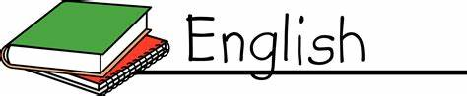
Fourth grade English involves more in-depth and detailed writing pieces. Students will be guided to utilize and analyze writing with the skills from grammar studies, language skills, and use of literary conventions. Tests will also be given on grammar and weekly word work.

Writing:
- The Writing Process
- Self and Peer Editing
- Paragraph Structure
- Personal Narratives
- Persuasive Writing
- Expository Writing
- Poetry

Grammar:
- Sentences
- Nouns
- Pronouns
- Verbs
- Adjectives
- Adverbs
- Prepositions
- Sentence Studies

Weekly Word Work:
Each Friday, students will be given a word work list that focuses on spelling and vocabulary skills. Tests on those weekly skills will be given each Thursday unless specified by the teacher.
- Phonics skills (diphthongs, digraphs, blends)
- Prefixes and suffixes
- Synonyms and antonyms
- Homophones, homonyms, and homographs
- Greek/Latin roots
- Finding meaning in figurative language
- Reference sources
- Using context clues
- Shades of meaning

Handwriting:
Students who attended St. Anne Pacelli in third grade will be expected to write all assignments in all subject areas using D'Nealian cursive formation unless otherwise specified by the teacher. Those students who are new to St. Anne this school year will be expected to write assignments in cursive after Christmas.

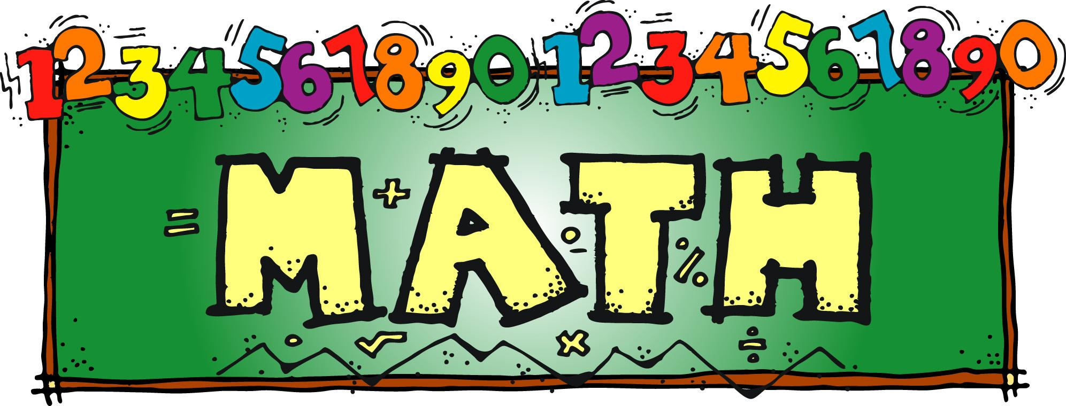
DRILLS - Mastery of basic math facts (addition, subtraction, multiplication, and division) is an essential tool for success in 4th grade math. A solid foundation in these areas allows your child to use them to build upon as we move to more complex content material. Drills will alternate weekly between the four operations during the 1st quarter.
DAILY REVIEW - Spiral review is a method of keeping material learned “fresh” and can also provide opportunities to introduce new concepts in smaller segments. Students will complete a “Daily Math Practice” as part of their morning work. These will be collected every 2 weeks and count as an effort grade.
LESSONS - We will use the Go Math consumable textbook as our primary source as we work through the Diocese of Savannah curriculum objectives for 4th grade. The text is also available online and includes opportunities for the students to work through tutorials and practice tests that correlate directly to each lesson/chapter. Each student will receive a Go Math username and password to use and a direct link to the Go Math website (www.thinkcentral.com) can be found on our 4th grade website (www.4avikings.weebly.com).
HOMEWORK -Each Monday through Thursday students will complete a column on a weekly math review page.
EXTRA PRACTICE–ThinkCentral assignments that correspond to lessons in class will be assigned as reviewed in class. If a student completes all lessons before the chapter test with a passing grade, they will earn 5 points on the test.
MORE EXTRA PRACTICE-Each student has an IXL account. Skills relating to the math chapter will be starred as we complete them in class.
MATH UNITS STUDIED-
- Place Value, Addition, and Subtraction to One Million
- Multiply 1-Digit Numbers
- Multiply 2-Digit Numbers
- Divide by 1-Digit Numbers
- Factors, Multiples, and Patterns
- Fraction Equivalence and Comparison
- Add and Subtract Fractions
- Multiply Fractions by Whole Numbers
- Relate Fractions and Decimals
- Geometry, Measurement, and Data (including perimeter and area)

Our 4th grade curriculum hits upon three major disciplines in science; Earth and Space, Life, and Physical. The topics we explore under each discipline are as follows:
Earth and Space
- Rotation and Revolution of the earth
- Phases of the moon
- Stars and planets
- Water Cycle and Weather
Physical
- Sound and Light
- Force and Motion
- Simple Machines
- Electrical Circuits
Life
- Roles of organisms and the flow of energy within an ecosystem
- Adaptations
In addition to the science book, each student will be keeping a science notebook (composition book). The notebooks are used to record vocabulary, classroom notes (especially for topics not covered in the textbook), and lab activities, etc. They are an important component of our daily science work, as well as a great tool for preparing for quizzes and tests. Regular notebook checks are part of the science grade. If your child is absent, it will be important for him/her to add any missed information to his/her notebook upon returning to school. A notebook will be in the class for this purpose.

Fourth grade social studies covers United States history from ancient Native American civilizations to pre-Civil War times. A study guide will be given to each student and posted on the class website before each test. Once a study guide is posted, students should begin reviewing each night for the upcoming test. Last minute cramming the night before a test is not a good study strategy. Students will study the following topics during their fourth grade year:

North American Geography
Ancient Native American Civilizations
European Exploration
Early European Colonies
British Colonial America
French and Indian War
American Revolution
A New Nation
War of 1812
Westward Expansion

Our textbook, WE Believe is used to support the Diocese of Savannah 4th grade curriculum guidelines.
This book is to be used as a textbook and cannot be written in this school year!
Topics we cover during the year include: the Sacraments, Prayer, the Rosary, the Liturgical Year, the Beatitudes, the Commandments, the Liturgy, Scripture, and Catholic Social Teaching. This year, 4th grade will present the Saints at the All Saints Day mass. A direct link to the Religion website (www.webelieveweb.com) is provided on our 4th grade website. Past students have found the review games provided on the site as a useful tool to prepare for tests. We participate in weekly masses each Thursday at 9:30 a.m. unless there is a Holy Day of Obligation or other Church celebration scheduled for another time that week.

The following prayer is taken from Mother’s Manual by A. Francis Coomes, S.J.
For a Child’s Success in Studies
Father of lights and of all true wisdom, I humbly recommend to you the success of my child in the pursuit of learning. Mercifully grant the measure of success that it will be good for him (her) to achieve. And thus, may there be a genuine sense of fulfillment as a result of efforts made.
May all knowledge attained be tempered by humility. Grant that my child’s endeavors may always be guided by a sense of solid values, and help me to instill these values. And so may all his (her) striving for knowledge be made, not with the aim of surpassing others or of making a vain show of ability, but rather as a worthy return to you of the talents that you have bestowed.
Above all else, I ask that every degree of knowledge achieved may bring my child to a greater closeness to you and to a more abundant share of your love.
Amen

